March 1, 2014
Dear Friends,
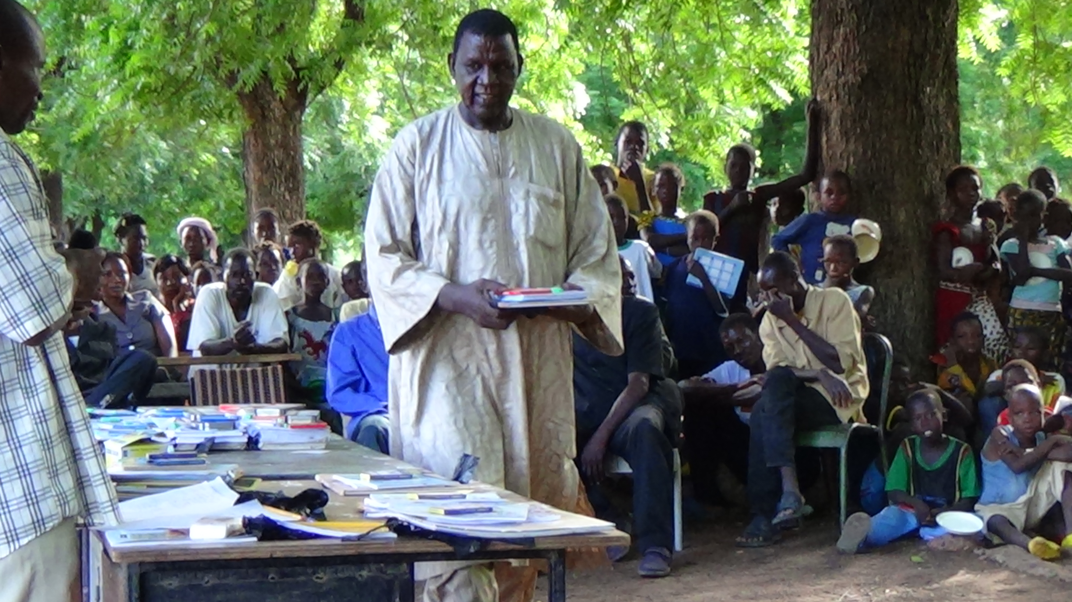
We just purchased our airplane tickets to go to Seyou, Bandiara, and Zinakongo in Burkina Faso. These are unreached villages in West Africa. Two are Muslim and the third is run by the witch doctors. Nicolas, who WOW has been supporting to further his education abroad, has done literacy work in these villages. Nicolas is working with us to produce another book of hope in the Jula language. Jula is a trade language. These people do not have any written literature in their mother tongue language.

We will also bring them moringa trees. There is little nutrition in the land, apart from a few fruit trees. These trees will help supplement the diets of nursing mothers and children, because they are high in calcium, fiber, antioxidants and iron.

Our first week we will do some training with youth and women in the larger village of Ouri, where we worked 20 years ago with Nicolas. We look forward to seeing and strengthening the work that Nicolas has done in Ouri and the surrounding areas. We want to help raise the bar and demonstrate how he can be even more effective in helping these subsistence farmers to become leaders to bring advances in health and education to the Burkinabe.

